## MERAJ ALAM KHAN

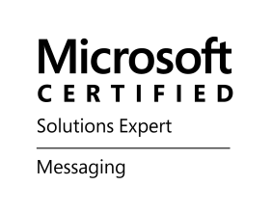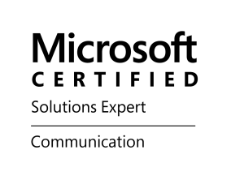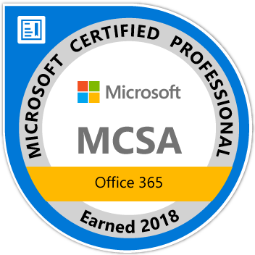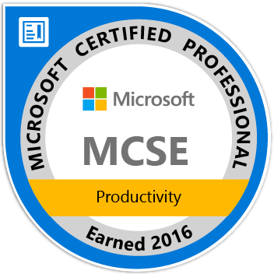

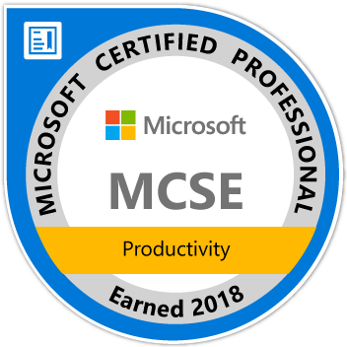 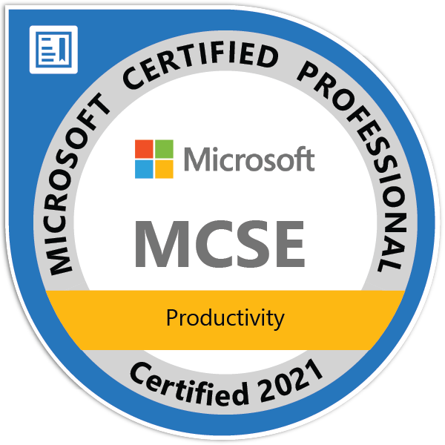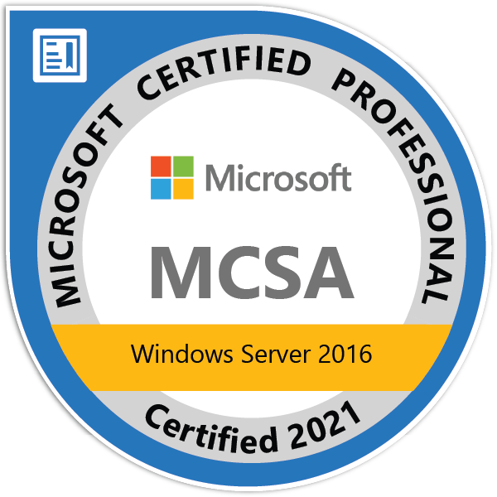 A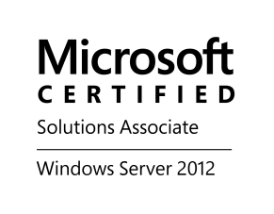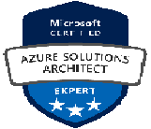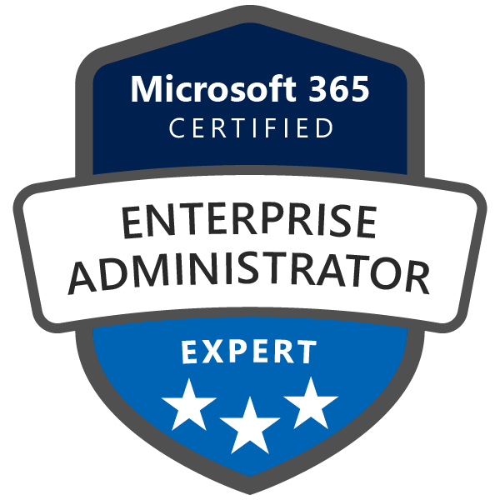

[Meraj.khan@hotmail.com](mailto:Meraj.khan@hotmail.com)

Phone +16099178026

**CERTIFICATIONS:**

**Certification on Azure**

Microsoft Certified: Azure Solutions Architect Expert

**Certification on Office 365**

Microsoft Certified Technology specialist, **MCTS**

Microsoft Certified IT Professional, **MCITP**

Microsoft Certified Solution Associates, **MCSA**

Microsoft 365 Certified: Enterprise Administrator Expert

**Certification on OCS/Lync server 2010/ 2013/Skype for Business 2015**

Microsoft Certified Technology specialist, **MCTS**

Microsoft Certified IT Professional, **MCITP**

Microsoft Certified Solution Expert Communication **MCSE**

**Certification on Exchange 2000, 2003, 2007, 2010, 2013, 2016**

Microsoft Certified System Engineer Messaging, Exchange 2000 & 2003

Microsoft Certified Technology specialist, Exchange 2007 and Exchange 2010

Microsoft Certified Solution Expert Messaging, Exchange 2013 and 2016

**Certification on WINDOWS 2008/2012/2016**

Microsoft Certified Technology specialist, **MCITP**

Microsoft Certified Technology specialist on Windows 7, **MCTS**

Microsoft Certified Solution Associates, **MCSA**

Microsoft Certified Solutions Engineer, **MCSE Productivity**

**Carrier objective**

To be in a position where in my credentials of being a Microsoft Certified Azure and O365 Solution Architect, other qualifications, with the expertise in the field of Identity management, infrastructure, Security, Cloud technologies, unified messaging and collaboration are used to the best. Along with which also have an opportunity to grow as an individual and professional which makes a positive contribution to the organization and customer satisfaction.

**Skills**

Cloud Technologies Office 365/Azure, GCP

Messaging Systems Microsoft Exchange 2016/2013/2010 /2007 /2003/2000/5.5 and 5.0

Server Operating systems Windows 2012, 2008, 2016,2019

Gateways and Anti-SPAM Ironport / Proofpoint / MessagLabs /Puremessage /TMG, Azure ATP

Communicator systems LCS 2005, OCS 2007 R2, Lync 2010, Lync 2013and Skype for Business

Identity management MIIS 2003, ILM 2007, FIM 2010 R2, MIM 2016, ADFS, AAD Connect

File Share & Data Management DFS, NetApp, SharePoint, OneDrive, Cisco Hyperflex 4.0

Archiving solutions Enterprise Vault, Autonomy, Actiance Vantage

Virtualization Hyper-V Server 2008 R2, 2012 R2, VMware Exsi 6.5, 6.7

Scripting tools Windows PowerShell and Azure PowerShell

Mobile Clients BlackBerry 10.0, MDM Airwatch, Microsoft Intune

UEBA Security Splunk, Varonis, Exabeam, Microsoft 365 Security and compliance centers

Data Analystics Platform Azure DataBricks, Azure Data Lake Analytics (ADLA), CosmoDV, SQL server

Automation and CM tools SCCM 2012, MECM, Puppet, Saltstack

**Summary**

* 16 years Onsite experience with retail clients like John Deere, Walgreens, FedEx, Pfizer, BP etc.
* 23 years of experience in Active Directory and Microsoft Windows platform.
* 18 years of experience in designing and architecting Active Directory Domains and Forests.
* 22 years of experience in Unified Messaging (Exchange, OCS/Lync/Skype for Business, Office 365).
* 5 years of experience in Project Management
* 17 years of experience in Archiving and Journaling including Enterprise Vault, Actiance Vantage and Mimecast.
* 12 years of Experience in designing, planning, solution delivery, administration and configuration of Microsoft 365 and Azure services and solutions.
* 9 years of experience in Azure Security, Cyber Security, Office365 security.
* 13 years of experience in Data Loss Prevention, Retention, Right Management Services, ATP/Microsoft Defender
* 18 years of experience in Windows PowerShell scripting.
* 10 years of experience is Azure Database services.
* More than 12 years of experience in moving mailboxes to Office 365/BPOS.
* Moved more than 250,000 mailboxes to Microsoft 365.
* Experience in Designing, deployment and migration from legacy Exchange environments and Lotus Notes to Exchange 2007/2010/2013 and O365/Microsoft 365.
* Experience in Designing, planning and deployment of On-premises to Online (O365) migration – and Hybrid Solutions.
* Worked as Solution Delivery Architect and assisted Customers in designing and deployment in cross-forest Migration of Exchange, AD and Lync/Skype for Business platforms.
* Experience in designing, planning, deployment, migration and administration of OCS, Lync, Skype for Business and Microsoft Teams.
* Deployment of Microsoft Teams and Yammer. Implementing telephony by using Microsoft Teams.
* Designing and deploying the Identity management solutions by using ILM 2007, FIM 2010 R2 and MIM 2016.
* Designing and Implementation of ADSF Farms and ADFS proxy solutions.
* Implementation of Azure AD connect and directory synchronization between On-Premises AD with Azure AD.
* Designing, planning and deployment of federations between On-premises and Online tenants.
* Deployment of Windows Servers, VM’s by using ARM templates and terraform.
* Design and implement the File Shares Management by using DFS and SharePoint/One Drive.
* Managing the Infrastructure through Azure IAAS, PAAS.
* Deployment, day-to-day administration of VM’s in Azure through ARM.
* Implementing Azure policies through ARM templates,
* Experience in implementing SQL server deployments and administration including Azure SQL Database/Elastic Pool, Azure SQL Managed Instance and SQL Server on Azure VMs.
* Migrating SQL Server to Azure SQL Database or an Azure SQL Managed Instance online using DMS.
* Working experience with Azure Synapse Analytics.
* Optimizes SQL environment with the SQL Server Health Check solution in Azure Monitor.
* Implementing Azure Blob Storage, Azure Data Lake Storage Gen1, Azure Data Lake Storage Gen2 and Azure Data Lake Analytics
* Understanding of Azure Pipelines.
* Automated platform provisioning by using Infrastructure as Code.
* Configuring Azure Data Factory and Implementing Azure Data Bricks.
* Upgrading from TFS server to Azure DevOps services by using Data Migration tool by using Azure DevOps.
* Designing, planning, and providing solutions related to Azure Container Instances, Docker, and Azure Kubernetes Services.
* Implementing best practices for container image management and security in Azure Kubernetes Service (AKS).
* Designing and planning Azure Kubernetes (AKS) Security Best Practices.
* Integration and Authentication with Azure Container Registry from Azure Kubernetes Service.
* Create templates to deploy ACR and AKS solutions.
* Designing and planning solutions related to DevOps/VSTS.
* Deploying ASP.NET app to Azure virtual machines by using Azure DevOps Starter.
* Deploying Azure SQL Database code by using Azure DevOps Starter.
* Experience in designing, configuring, and implementing the Azure Security and Compliance Center policies and UEBA security.
* Experience in third-party UEBA security tools by using Splunk, Varonis and Exabeam.
* Implementation of Azure Security Benchmark including the Vulnerability Management, Network Security, and Identity Management
* Administration and configuration of Azure security logging, Azure Log Analytics, and auditing.
* Experience in implementing Privileged Access Management, Azure AD Privileged Identity Management, RBAC, ABAC, and Identity and Access Control
* Experience in designing and configuring Conditional Access policies, compliance policies, e-governance
* Experience in designing, implementation and configuring Data Labeling, Data Classification, Azure Information Protection, Data Loss Prevention policies, Microsoft Cloud App Security and Azure Information Rights Protection
* Experience in administration of Microsoft Intune, Microsoft Defender for Identity and Microsoft Endpoint Configuration Manager
* Experience in Co-Management, Windows Autopilot and Desktop Analytics.
* Implementing and designing the solutions for Azure Backup services, Azure Site Recovery, and Azure Migrate.
* Designing and planning experience in Google Cloud online storage products.
* Experience in GCP Operations suite (formerly Stackdriver).
* Experience in GCP IAM and Security.

|  |  |
| --- | --- |
| **EXPERIENCE**  **AVCO Consulting March 2022 till now**  **Designation: DevOps Engineer, FTE**  **Client Projects:**  **Hewlett Packard Enterprise, Spring, Tx**  **Senior Azure AD and IAM Architect/Project Manager from October 2022 till now**   * Applies new solutions through research and collaboration with team and determines course of action for new application initiatives. * Oversee projects, including planning, assigning, monitoring, and reviewing progress and accuracy of work * Leading the team as project manager and senior solution architect. * Creating the project plan and updating it as per the progress. * Engaging the resources with the project * Ensure project resources align to the project timelines. * Timely discussion of the project issues with the management and the team. * Following tand implementing the he Agile methodology in the projects. * Assigning the tasks to the team resources. * Creating and arranging the status and follow-up meeting with the vendors, contractors, team members and management. * Infrastructure Health Monitoring * Implementing low level delegation of access within Active Directory * Understanding of Active Directory security audit data points and best practices for security settings * Performing large scale upgrades, migrations, transitions and consolidation of Active Directory domains and forests * GPO design, analysis, and implementation * Providing operational 4th level support for large-scale enterprise level AD environments * Troubleshooting Active Directory performance, authentication, and replication issues * Troubleshoot AD issues (replication, DNS, Sylvol, etc.) * Federated Identity Management, Azure ADFS, and third-party federated services AD/AAD integration support (AAD connect, AAD support) * Collaborate and integrate AD with other directories and applications * Application integrations to AD (ex. SailPoint, Okta, etc.) * Integration of Salesforce with Office 365 * Connecting Salesforce and Microsoft® Exchange Using OAuth 2.0 * Migration of AD from DXE datacenter to HPE Datacenter * Migration of FIM2010 R2 to new Hardware Platform by using VMware P2V solution and then to Microsoft Identity Manager 2016 service pack 2   **PIMCO, Austin, Tx**  **Senior Unified Messaging Architect from Jan 2022 till March 2023**   * Supporting Exchange 2016 and O365 Hybrid environment. * Migrating mailboxes to Microsoft 265 * Enabling user accounts for Microsoft Teams including the web conferencing. * Administration of Microsoft Teams and Exchange environment * Managing Global policies related to Teams, SharePoint, and One Drive * Federated Identity Management, Azure ADFS, and third-party federated services AD/AAD integration support (AAD connect, AAD support) * Participating in the CAB and ARB meetings * Follow the ITIL process. * Maintenance and patching of the Exchange Servers.   **AAA, Coppell, Tx**  **DepOps/MFA Engineer from May 2022 till now**   * + - * Design, Administer, and Support of Active Directory Services for on-prem.       * Design, Administer, and Support of Active Directory Services for Azure AD.       * Design, Administer, and Support of MFA using Thales on-prem solution.       * Design and implement Azure B2C solutions       * Implementing Conditional Access policies.       * Design, Administer, and Support of Privilege Access Management system using CyberARK for Vaulting, JIT, and PSM       * Administer and Support PKI infrastructure using Microsoft CMS and Keyfactor       * Collaborate in Agile Team ceremonies.       * Provide technical training and consultation to other members of the IT organization.       * Help in troubleshooting to resolve production system problems.       * Participate in the automation of deployments in a CI/CD pipeline.       * Investigate and recommend new methods, procedures, tools, and technologies.       * Participate with other IT professionals to evaluate new technologies in the market and recommend cohesive direction for the IT organization.   **AbbVie, Chicago, IL**  **MS Office 365 Collaboration & Conferencing Governance Spclst/Project managerfrom March 2022 to April 2022**   * + - * Designing the compliance and security policies for the Office 365 tenant.       * Implementing the Azure Information Protection.       * Administering the Compliance and Security Centre of the Office 365 tenant.       * Creating the project plan.       * Implementing the tasks mentioned in the project plan.       * Following the Kanban board.       * Providing timely updates to the IT managers and directors.       * Collaboration with the other teams       * Troubleshooting the day-to-day issues related to Security, Office 365.       * Design and delivery of governance capabilities for Collaboration and Conferencing and related services with a focus on Microsoft 365 ecosystem and Conferencing technologies.       * Administration, management, and implementation of the retention policies, records, and data.       * Assessment of the current security, compliance, and governance environment.       * Designing, implementing, and administrating the Data Loss Prevention policies for Microsoft 365 workloads.       * Analyzing the reports related to security, governance, and compliance.       * Administering and managing the Auditing and Alert policies for Microsoft 365 workloads.       * Implementing and configuring the Microsoft 365 eDiscovery solutions. * **Royal Technocrats September 2019 till January 2022**   **Designation: Azure Solution Architect, FTE**  **Client Projects:**  **Northern Trust, Chicago, IL**  **Azure/O365 Solution Architect/Project Lead from September 2021 onwards**   * + - * Designing, planning and migration from Exchange 2016 to Office 365.       * Designing, planning and migration of 16,000 accounts from Skype for Business 2015 On-premises to Microsoft Teams       * Establishing Coexistence with Skype for Business and Microsoft Teams.       * Work on the escalated issues from O365, Azure AD, Skype for Business, Compliance and Exchange Team       * Planning and implementation of PSTN connectivity options.       * Telephony cutover from Skype for Business on-premises with Microsoft Team calling plans and AudioCodes devices or Soft client on end user system.       * Implementing Record Management with Microsoft Teams.       * Implementation of Microsoft Cloud App Security which is a Cloud Access Security Broker (CASB)       * Enabling Office 365 Lockbox and Azure Lockbox in both the tenants.       * Implementing Azure Information Protection       * Implementing PIM in Azure       * Implementing Event-based retention for SharePoint and One Drive.       * Implementing Adoptive Scope based retention in the SharePoint and One Drive.       * Implementing Records Management for SharePoint, OneDrive and Exchange.       * Managing Audit and Alert Policies for Microsoft 365.       * Planning DLP policies in Exchange and SharePoint online.   **St. Luke's University Health Network, Allentown, PA**  **Microsoft Active Directory and IAM Security Architect/Project Manager from January 2021 till August 2021**   * Designing and planning for Azure B2C tenant. * Implementation of Microsoft Cloud App Security which is a Cloud Access Security Broker (CASB) * Design and Implement Multi Factor Authentication (MFA). * Integration of EPIC with Azure B2C tenant. * Configuring Azure B2C as IDP to MyChart application. * Configuring MyChart to communicate between Azure B2C and EPIC system. * Integration of third-party identity provider to your Azure Active Directory B2C tenant. * Migrating users form on premise AD to Azure AD B2C tenant. * Implementing Best Practices for Security, Migration, User flows, Policies and Directory cleanup in Azure B2C tenant. * Registering applications in Azure B2C tenant. * implementing Privileged Access Management, Azure AD Privileged Identity Management, RBAC, ABAC and Identity and Access Control * Upgrading TFS 2018 to Azure DevOps services. * Deploying ASP.net app by using Azure DeOps Starter. * Providing access of the apps to the external users, internal users and third-party vendors in Azure B2C tenant. * Implementing solution for Microsoft Endpoint Manager for Co-Management and Configuration Manager. * Implementation of Azure Security policies in Production and B2C tenant. * Implementation of Azure load balancer, and application gateway. * IAM solution with GCP platform.   **City of Hope, Duarte, CA**  **Azure Security/O365 Solution Architect/Project Manager from January 2020 to December 2020**   * Managing multiple projects by following the Agile Methodology. * Designing and planning for migration of users 12,000 mailboxes to O365 * Installation of Exchange 2013Hybrid Servers. * Office 365 remediation project. * Created the project plan. * Coordinating with collaborative teams. * Timely communication with the team and management on project milestones and issues. * Designing and Implementation of Microsoft Intune with IOS and Android devices. * Administration and configuration of Microsoft Intune, Microsoft Defender for Identity and Microsoft Endpoint Configuration Manager. * This project includes the pre-sales experience for Office 365 and Azure services. * Implementation of Data Loss Preventions Policies Privileged Identity Management, Access Management and Azure information protection policies. * Troubleshooting post migration issues related to Exchange mailboxes. * Migration of users and shared mailboxes to Exchange Online. * Migration of on-premises Public folders to Office 365. * Decommissioning of Exchange 2007 and Exchange 2010 servers * Implementing DLP, Data Classification, Right Management and Conditional Access Policies * Implementation of Microsoft Cloud App Security which is a Cloud Access Security Broker (CASB) * Design and Implement Modern Authentication. * Enablement and Configuration for Microsoft 365 security center and Microsoft 365 compliance center * Installation and Configuration of Azure AD Connect * Integration of Salesforce with Office 365 * Migration of user accounts from Lync 2013 to Skype for Business Online * Implementation of Microsoft Teams and Co-existence with Skype for Business. * Implementation of Telephony for Microsoft Teams clients. * Troubleshooting issues related to Skype for Business/Microsoft teams. * Implementing Global Policies with Microsoft Teams. * Configuring Auto Attendants and Call Queues in Teams. * Moving data from personal drives to One Drive for Business * Providing solution for Migration of Data from Net App files share and Windows Files Server to Azure NetApp Files and Azure File Share * Implementation solution of Microsoft Defender for Identity. * Providing solutions to vulnerability management, Azure Log Analytics and Azure Monitoring. * Deploying Azure Kubernetes Service (AKS) cluster. * Designing security baseline for Azure Kubernetes Service. * Deploying applications in Azure Kubernetes Service (AKS). * Optimizing applications in Azure Kubernetes Service (AKS) * Upgrading TFS 2013 to Azure DevOps services. * Deployment and Administration of SQL Server 2019 * Installation of Configuration Manager Current Branch 2002 Infrastructure * Migration of Software Packages from Altiris to Configuration Manager Current Branch 2002 * Automation and Installation the Software updates to Servers and Workstations * Deploying the Windows Clients through Configuration Manager Current Branch 2002 * Microsoft Endpoint Manager for Co-Management, Configuration Manager, Windows Autopilot and Desktop Analytics * Working on Designing AD 2012 Migration to Azure AD and Windows 2019 Hybrid.   **Stratum Reservoir– Azure VM and Data Migration, Houston, Tx from October 2019 to December 2019**   * Designing, planning and implementation of migration of users account from Skype for Business on-premise and Exchange 2013 to O365 and Microsoft Teams. * Designing. planning and implementation of O365 features, security, DLP's, O365 backup, Intune, Microsoft Teams, SharePoint Online. * Enabling the security features in O365/Azure. Provisioning the accounts in O365 and enabling the features. * Design and deployment of Server infrastructure in Azure. * Management and administration of Azure AD. * Deployment of Windows 2016 servers by using ARM templates. * Migration 22 Virtual Machines from on-premise AD to Azure by using ASR and VHD's. * Designing and implementation of Azure NetApps Files. * Implementation of key Azure services - VM, Storage, Azure SQL, VNet, Redis Cache, Resource Manager, Azure Diagnostics/OMS, Traffic Manager, Azure CDN, Azure Notification Hubs, Azure Identity and Access Management, Infrastructure as Code and Automation etc.. * Enable Multi-Factor Authentication and Conditional Access in Azure/Office 365. * Implement Azure Information Protection and Privileged Identity Management. * Monitor and Report the tenant infrastructure and services. * Practice DR Strategy and Implementation experience in Azure environment by planning and implementing Azure Site Recovery (ASR). * Enabling the security features in O365/Azure. Provisioning the accounts in O365 and enabling the features. * Administer the networking aspects on cloud, defining network security groups, policies, configuring load balancers, application gateways. * Knowledge of best practices and market trends pertaining to Azure/O365 to provide thought leadership (seminars, whitepapers etc.,) and mentor team to build necessary competency. * Enablement and Configuration for Microsoft 365 security center and Microsoft 365 compliance center * Design and planning for Microsoft Teams * Planning for Telephony cutover to Microsoft Teams. * Design and implement Azure Data Bricks, Configure policies through Azure Security Center. * Configuring Azure Data Factory. * Analyzing data through Azure Synapse Analytics * Preparing the document on storage options comparison between Azure and GCP.   **Vicom Computer Services Inc. April 2018 till August 2019**  **Designation: Solution Delivery Architect/Project Manager, FTE**  **Role and Responsibilities:**   * Assessment of the existing infrastructure. * Developing and documentation of Statement of Work (SOW's) and presenting to the clients based on the assessment. * Designing, planning and implementation of migration of users accounts from Lync to Skype for Business on premise and Lync and Skype for Business to Skype for Business online/Microsoft Teams. * Designing. planning and implementation of O365 features, security, DLP's, O365 backup, Intune, Microsoft Teams, SharePoint online. * This project includes the pre-sales experience for Office 365 and Azure services. * Meeting with clients, recording their problem statement or issues, wrote the SOW’s, proposed the solutions and implement the solutions. * Enabling the security features in O365/Azure. Provisioning the accounts in O365 and enabling the features. * Providing end user training documentation and SOP’s to the service desk/help desk. * Designing and implementing Identity management Solutions, ADFS and Azure AD Connect. Integration of other Identity management solutions with Azure AD Connect like Ping Federate. * Implementing Azure Security Architecture best practices and Azure Policies. * Deployment and configuration of Polycom trio and Vvx series desktop phones. * Design and deployment of Server infrastructure in Azure by suing Azure Site Recovery and ARM templates . * Management and administration of Azure AD. * Migration of Exchange mailboxes and SharePoint data to O365 by using BigTitan Migration Wizard. * Implementing Mimecast and EOP solutions for email security, archiving and journaling. * Porting of the existing telephony to O365. * Implementing Intune policies and Co-Management * Configuring Desktop Analytics * Implementing and configuring Azure Data Factory and Azure Data Lake. * Implement Azure Data Bricks and Azure Data Lake Analytics Concepts. * Day to day administration and data analysis through Azure Synapse Analytics. * Deployment of Server infrastructure by using ARM templates and Terraform. * Providing solutions to Azure Containers Instances and Azure Kubernetes Services. * Multi-tasking and worked on multiple projects of different clients simultaneously. * Planning and designing the storage and networking solutions in GCP   **Clients Projects worked on:**  **Horizon Blue Cross Blue Shield – O365 migration, Newark, NJ**   * Installation and Configuration of Azure AD Connect. * Design and Implement MFA. * Deployment of Exchange 2016 Hybrid environment. * Migration of mailboxes to O365 using BitTitan Migration Wizard. * Installation and Configuration of Splunk to use for O365 Monitoring and Azure Audit Logs. * Deployment and configuring the backup solution for SharePoint and O365 mailboxes by using Spanning * Configuring and deployment of Data Protection for O365 Mailboxes and Sharepoint by using Varonis. * Configuration and deployment of SkyHigh and CASB for O365 * Leveraging O365's e-discovery capabilities to secure and search documents by deploying and configuring Exterro for Exchange, SharePoint and OneDrive. * Implementing authentication by using Azure AD Connect through Ping Federation. * Configuring Data Classification and Right Management in O365. * Integration of Salesforce with Office 365 * Configuring Data Classification and Secure Messaging by using Bolden James for Exchange and SharePoint. * Implementation of UEBA security by using Splunk and Microsoft 365 Security Center. * Implementing solutions related to DLP, Conditional Access, PIM, Privileged Access Management, Azure Information protection, RBAC and e-governance. * Designing, planning and installation of SQL server 2016 with High Availability solution * Deployments of VM by using Terraform. * Implementation and providing solution of VM’s in Azure, NSG, Azure Firewall and Azure Application gateways. * Migrating VM’s by using Azure Migrate. * Deploying and using Azure Container Registry (ACR). * Deploying Azure Kubernetes Service (AKS) cluster. * Designing security baseline for Azure Kubernetes Service. * Deploying CI/CD Data Pipelines using ADF and Azure DevOps. * Designing, planning and implementation of Azure Site Recovery and Azure Backup Services. * Implementing Intune policies and Co-Management * Configuring Desktop Analytics   **Horizon Blue Cross Blue Shield – Lync 2010 to Skype for Business 2015 migration, Newark, NJ**  • Deployment and Configuration of Skype for Business 2015 Front-end pools.  • Deployment and Configuration of Skype for Business 2015 Edge server pools  • Installation of SQL 2014 backend servers with AlwaysOn Availability group.  • Migration of Lync 2010 users to Skype for Business.  • Installation and Configuration of Actiance Vantage for Skype for Business Archiving.  • Deployment and configuring of Office Online Server farm.  **Noramco Inc., O365 deployment Philadelphia, PA**  • Deployment and Configuration of MimeCast for Email protection and Scanning  • Configuring MimeCast for Archiving and Journaling  • Installation and Configuration of Azure AD Connect  • Provision user accounts for Skype for Business online and Microsoft Teams.  • Enabling UEBA security by using Exabeam and Microsoft 365 Security Center.  • Configuring documents libraries in SharePoint Online.  • Migrating Data from SharePoint on-premise to SharePoint online  • Configuring the data classification in SharePoint Online.  **WCG Clinical, Cross-forest migration and O365 deployment into single tenant, Princeton, NJ**  • Cross forest migration of accounts and data of 14 companies to one O365 tenant.  • Design and Implement MFA. Implementing UEBA security by using Splunk.  • Migration of Exchange mailboxes from On-premise Exchange 2013 to O365 by using BitTitan  • Migration of accounts from Gmail Suite to O365 using BitTitan.  • Cross Tenant migration in O365 by using BitTitan.  • Migration of user data to OneDrive by using BitTitan Migration Wiz.  • Implementing Azure AD Connect for authentication and Identity management.  • Provisioning Skype for Business account and enabling accounts for Voice  • Configuring Auto Attendants and Call Queues in Teams.  • Implementing O365 Telephony. Enabling users for O365 Groups and Microsoft Teams  • Implementing solutions related to DLP, Conditional Access, PIM, Privileged Access Management, Azure Information protection, RBAC and e-governance.  • Implementing Intune policies and Co-Management  • Configuring Desktop Analytics  • Deployment of Microsoft CASB and Data Classification in O365  **Arizona Beverages – Woddbury, NJ**  • Design and Implement MFA.  • Rebuilding a new AD forest after a ransomware attack  • Using PowerShell added groups, generated unique passwords for accounts and adding members to security groups and DL.  • Design and implement Exchange 2013 disaster recovery.  • Rebuilding NetBackup 8.1.2 Master Server  • Restored Exchange 2010 and 2013 stores by using NetBackup  • Installing and Configuring AZURE AD connect  • Merging mailbox data and migrating accounts from one tenant to other in O365 by using MigrationWiz  **Heat Makes Sense O365 deployment**  • Design and Implement MFA.  • Installing and Configuring AZURE AD connect  • Cross Tenant migration in O365 by using BitTitan Migration Wizard.  • Porting numbers and Telephony cutover from vendors to Microsoft O365 Telephony  • Provisioning Skype for Business account and enabling accounts for Voice  • Configuring Auto Attendants and Call Queues in Teams along with O365 telephony.  • Implementing UEBA security by using Varonis and Microsoft 365 Security Center.  • Enabling users for O365 Groups and Microsoft Teams.  • Migration of data and documents from one tenant to other for SharePoint Online  • Migration of user data to OneDrive by using BitTitan Migration Wiz.    **Collaborate Solutions Inc. July 2013 till April 2018**  **Designation: Messaging/O365 Architect, FTE**  **Roles and Responsibilities:**   * Assessment of the existing infrastructure. * Designing, planning and implementation of migration of users accounts from Lync to Skype for Business on-premise and Lync and Skype for Business to Skype for Business online/Microsoft Teams. * Designing, planning and implementation of O365 features including security, DLP's, O365 backup, Intune, Microsoft Teams, MDM and Data Classification. * Designing and implementing Identity management Solutions, ADFS and Azure AD Connect. * Administration of existing Exchange, Active Directory, Lync/Skype for Business infrastructure. * Design and deployment of Server infrastructure in Azure. * Day to day Administration, Monitoring and reporting of Azure infrastructure. * Participating in the Change Management process to implement RFC's. * Monitoring and reporting the exisitng infrastructue.   **Clients Projects worked on:**  **State of Utah Transport Authority, Salt Lake City, UT December 2017 –till February 2018**     * Assessment for O365 migration of Exchange, Skype for Business, SharePoint and Active Directory * Designing and planning for ADFS Farm and ADFS proxies. * Deployment of ADFS Farm and Proxies. * Designing and Implementation of SQL server 2014 WSFC Always on Availability Group. * Implementing Certificate Authorities and PKI infrastructure in Azure. * Design and Deployment of Azure AD connect. * Creation and Deployment of VM’s in Azure by using ARM templates. * Design and implementation of Azure Site Recovery of VM’s. * Moving existing Apps to the Azure. * Designing and Deployment of Test and Development environment for VSTS/DevOps use. * Providing solutions for Azure Containers and AKS. * Upgrading TFS 2013 to Azure DevOps Services. * Designing for Best practices for security for Office365, Azure including DLP, Intune/MDM, MFA, Azure logging and threat analytics. * Privileged Identity Management in Azure.   **VMWare, Palo Alto, CA December 2016 –December 2017**   * Assessment for O365 migration of Exchange, Skype for Business, SharePoint. * Deployment of Skype for Business 2015 infrastructure. * Migration from Exchange 2013 to O365. * Migration from Lync 2013 to Skype for Business 2015. * Lync Mobility deployment. * Post Migrations support and tasks. * Administration and maintenance of present infrastructure and Hybrid infrastructure. * Troubleshooting the escalated end client issues related to Skype for Business/Teams and Exchange. * Deployment of Microsoft Teams and Yammer Pilot projects. * Administration of Yammer and Microsoft Teams. * Monitoring health of the servers and troubleshoot the server related issue. * Change management including the RFC implementation and approval.   **McLane Corp. Dallas, Tx November 2016- December 2016**   * Deployment of Skype for Business 2015 infrastructure. * Deployment of EDGE pool * Deployment of Citrix NetScaler as HLB and Reverse Proxy. * Lync Mobility deployment. * Migration of 4200 users from Lync 2010 to Skype for Business 2015 * Post Migrations support and tasks. * Assessment for O365 migration of Skype for Business. * Designing, planning and installation of SQL server 2014 with High Availability solution * Deployment of Skype for Business Management Pack SCOM 2016 for monitoring.   **John Deere. Moline, IL June 2016 –November 2016**   * Deployment of Skype for Business 2015 infrastructure. * Provisioning 35,000 users in Azure by using Azure AD Connect. * Migration of 35,000 Lync 2013 accounts to Skype for Business 2015 platform. * Health Check of existing Lync 2013 infrastructure and implementing the best practices including SCOM. * Designing and Deployment of the SCOM 2012 dashboard for SLA’s and Lync/Exchange Services. * Publishing the dashboards by using SharePoint portal. * Troubleshooting post migration and escalated issues related to Lync 2013/Skype for Business. * Troubleshooting performance and KHI issues for Lync 2013 and Skype for Business servers. * Upgrading the AD infrastructure from Windows 2008 to Window 2012 R2. * Designing the DFS solution. * Designing and planning for Skype for Business 2016 clients for the end users. * Planning for Exchange 2013 migration to office365 for 55,000 mailboxes including the DLP, Intune/MDM and EOP administration. * Migration of Pilot Users Mailbox from Exchange 2010 to Office 365. * Deployment of Office 2016 pro through SCCM. * Designing, planning and deployment solution of upgrading Lync 2010 to Skype for business 2015 for Nortrax. * Migration of 1210 users in Nortrax environment to Skype for Business 2015 platform from Lync 2010. * Deploying the VM’s in Azure. * Administration and atomization through Puppet   **Imprivata, Lexington, MA May 2016 till June 2016**     * Deployment of Exchange Hybrid solution in Office365/Azure for 550 users. * ADFS 2.0 farm deployment in Azure and federation with Office365. * Migration of 550 mailboxes to Office365 for Exchange 2013 on premise. * Designing, planning and deployment of SCCM 2012. * Deployment of Office 2016 clients through SCCM. * Configuring SCOM 2012 for present infrastructure AD and Exchange. * Implementing Azure PIM, Threat analytics, DLP, Intune/MDM and Best Practices for security. * Planning the data from present clients and network shares to One Drive online.   **Microsoft Fast Track Engineer, Remote December 2015 till May 2016**     * This role was pre-sales role for Skype for Business and Office 365/Azure services * Contacting the Microsoft premier clients and understanding their requirements and challenges. * Recording the problem statements and providing solutioning to the upgrade path. * Providing the POC’s or Demo related to the product features. * Providing the solutioning related to the upgrade path to Skype for Business 2015 from Lync 2010/2013 or OCS 2007. * Working with multiple clients at a time. * Assisting customers in Office 365/ Azure services enablement and configuration * Once client ready for the upgrade or transitioning, involving the Microsoft Consulting Services to takeover the implementation.   **Capital One, Richmond, VA May 5th2014 till April 30th2016**   * Designing and planning for migration of 40,000 mailboxes to Office 365 (Hybrid deployment). * Migration of Pilot Users Batch to Office 375 from Exchange 2007. * Establishing and provisioning users in Azure and Office365. * Planning for Lync Hybrid deployment and virtualization options for Lync and Exchange VM’s in Azure. * Planning for archiving solution for Exchange and Lync users. * Project lead for Datacenter migration of existing Lync/OCS infrastructure to new datacenters. * Troubleshooting post office 365 migration and escalated issues related to Lync 2013 and Exchange 2013. * Designing and Deployment Skype for Business clients for the end users. * Migration of 55,000 users from OCS 2007 R2 to Lync 2013 platform. * Administration of Lync 2013 and OCS 2007 R2 servers. * Planning and Deployment of Persistent Chat servers. * Deployment of Lync mobility and External Access * Planning and Deployment of Enterprise Voice solution. * Designing and deployment of HA solution and DR site for Lync 2013. * Troubleshooting post migration and escalated issues related to Lync 2013. * Designing and architect Voice integration in Lync 2013. * Designing and Deployment Skype for Business 2016 clients for the end users. * Enabling services in Office 365. * Managing the Lync 2013 infrastructure through SCOM 2012. * Deployment of Office 2016 pro through SCCM. * Monitoring and administration of the infrastructure through SCCM. * Designing and implementation of DLP, Intune/MDM, PIM and AD RMS.   **Jackson Life Insurance, Lansing, MI Nov 03 2014 till April 2015**   * Cross Forest Migration of 2000 Lync 2010 to Lync 2013 users. * Cross Forest Migration 6000 users from Exchange 2010 to Exchange 2013. * Planning and Deployment of Persistent Chat servers. * Planning and Deployment of Enterprise Voice solution. * Co-existence between Lync 2013 and OCS 2007 R2. * Deployment of Lync mobility and Federation with Partners. * Designing and deployment of HA and DR site for Lync 2013and Exchange 2013. * Migration of 5500 users from Exchange 2010 to Exchange 2013. * Cross forest migration of 2200 users from Exchange 2010 to Exchange 2013. * Designing, planning and deployment of hybrid environment for Lync 2013 and Exchange 2013. * Troubleshooting post migration and escalated issues related to Exchange 2013 and Lync 2013. * Designing and Deploying Enterprise Voice solutions for Lync 2013. * Deployment of SCOM 2012 R2 servers for monitoring AD, Exchange and Lync servers. * Solutioning for DFS in the newly built forest for file shares. * Promoted to project lead for Lync Hybrid deployment.   **FedEx Corporation, Memphis, TN Nov 122013 till May 02, 2014**     * Migration Iplanet mailboxes to Exchange 2013 platform. * Administration and management of Exchange 2010, Exchange 2007, Exchange 2013 and Exchange 2003 servers. * Administration 150,000 exchange mailboxes and 175,000 iplanet users. * Administration and management of archived mails by using Enterprise vault. * Troubleshooting issue related to Exchange, mail flow and Outlook clients. * Designing, planning and Migration of 2000 users from Domino/Lotus Notes 8.5.3 to Office365.   **Wellington Wealth Management, Marlborough, MA July 2013 till Nov 2013**   * Decommissioning of Lync 2010. * Assessment of Present OCS 2007 R2 and Exchange 2010 infrastructure for the deployment of Lync 2013 and Exchange 2010. * Designing and planning for the migration from OCS 2007 R2 to Lync 2013 along with Microsoft Consulting Services. * Implementation of Actiance Vantage for archiving the instant messages from OCS 2007 R2. * Assessment of the present OCS 2007 R2 infrastructure for the implementation of Enterprise Voice. * Migration of 75,000 Public folders from Exchange 2003 to Exchange 2010. * Decommissioning of Exchange 2003 environment. * Migrating data from DFS to SharePoint. * Migration of data from DFS to Document Library (SharePoint 2013 On-Premise). * Migration of Public folders objects and Distribution Lists across domain by using Quest migration manager for AD. * Designing and planning for migration from Exchange 2010 to Exchange 2013. * Administration and Monitoring SCOM 2008 for Exchange/Lync/Domain Controllers. * Troubleshooting escalated issues related to Enterprise Vault 10.0, Exchange 2010 and OCS 2007 R2.   **Data Glove Inc. June 2012 till July 2013**  **Designation: Senior System Engineer, FTE**  **Roles and Responsibilities:**   * Assessment of the existing infrastructure. * Designing, planning and migration of migration of mailboxes from Exchange on-premise to O365 * Designing and implementing Identity management Solutions, ADFS and Azure AD Connect. * Designing and migration of user accounts from OCS to Lync 2010. * Enabling enterprise Voice. * Designing, planning and migrating cross forest AD accounts. * Designing and Deployment of ADFS infrastructure and Diry sync for directory synchronization to Azure AD. * Day to day administration of existing Exchange, Active Directory, Lync infrastructure. * Participating in the Change Management process to implement RFC's. * Monitoring and reporting the existing infrastructure   .  **Clients Projects worked on:**  **Avaya, Basking Ridge,NJ June-July 2012**   * Cross Forest interorg replication, calendar sharing and migration and implementation * Cross forest inter-organization replication and calendar sharing between 25000 users of two different companies. * Both forests were Windows 2008 AD, one Exchange forest having Exchange 2010 and other having Exchange 2007. * FIM 2010 was used for cross forest replication and calendar sharing. * Designed, planned and presented the migration strategy after doing the assessment and discovery. * Provided co-existence between both AD and Exchange forest. * Migration of AD objects and Exchange mailboxes by using ADMT tool.   **AAA/Club, Phoenix, AZ July-Aug 2012**   * AD/Exchange/Lync Office 365 design and planning migration strategy and implementation * Subsidiary company (Club) AD and messaging infrastructure hosted in parent company AAA. Planning to move messaging infrastructure to cloud and managing its own a new AD forest. * Namespace will be shared between both the identities till parent company decides to go with a different namespace. * Planned and designed the migration strategy for moving 10000 AD accounts to new forest and 5000 exchange mailboxes to O365. * Planned for having new UPN suffix for the AD objects after cross forest migration. * Designed and planned for the new AD forest creation and migration. * Designing and implementation of ADFS and Forest trusts * Designed and planned for the Lync 2010 user’s migration to O365. * Designed and planned the mail flow in which all the inbound and outbound mails go through with parent company FOPE. * Designed and planned for the archiving, legal hold, journaling, retention polices after mailboxes moved to O365 online. * Designed and planned for co-existence between new AD forest and Office 365 with single sing on enabled. * Migration of pilot batch of 50 users from Exchange 2007 to Office 365.   **Data Glove Inc, Princeton, NJ Aug 2012- Dec 2012**   * Transitioning from Windows 2008 to Windows 2012, Exchange 2010 to Exchange 2013 and Lync 2010 to Lync 2013 * Designing, planning and implementation for upgrading the AD and DNS environment from Windows 2008 to Windows 2012 serves for 500 users. * Designing, planning and implementation for upgrading the Exchange 2010 forest to Exchange 2013 forest for 400 users. * Designing, planning and implementation for upgrading the Lync 2010 server to Lync 2013 for 200 users including the enterprise voice. * Planning and Deploying Lync 2013 clients for 300 users. * Planned and implementation the DNS infrastructure for windows 2013 environment.   **Walgreens, Lincolnshire, IL Dec 20012 to July 2013**   * Migration from on-premise Exchange environment to Office 365 cloud * Migration of 40,000 mailboxes from Exchange to premise to O365 cloud. * Troubleshooting the post-migration issues related to Exchange online. * Day to day administration of Exchange and O265 hybrid environment. * Troubleshooting escalated end user issues related to on premise Exchange or Office 365. * Administration and management of Client Mobility and Active Sync issues. * Administration of email gateways.   **IBM Pvt Ltd. November 2009 till May 2012**  **Designation: Advisory Technology Services Specialist, FTE**  **SME LEAD, Unified Messaging and infrastructure Consultant (L4/L5 Engineer)**  **Locations: Houston TX, London (UK), Melbourne (AUS) and Bangalore/Noida (India)**  **Clients: BP, BHP Billiton, Suncor, Bank of Ireland, DLF**   * Cross-forest migration from Windows 2003 to Windows 2008 and Exchange 2003 to Exchange 2007/2010 by using Quest and ADMT tools. * Migration from OCS 2007 R2 to Lync 2010 platform. * Day to day administration of OCS 2007 R2/Lync 2010 infrastructure. * Troubleshooting escalated issue related to OCS 2007 and Lync 2010 end users issues. * Design, implementation and administration of AD infrastructure in multi-forest, multi domain environments. * Designing AD infrastructures which were scalable, redundant and completely free of single point of failure. * Administration of Enterprise Vault, Exchange server mailbox and public folder arching by using Enterprise Vault. * Office 365 migrations of Lync, AD accounts and mailboxes from on-premises by either hybrid rich co-existence or cut over method. * Migration from Dominos 8.0 to Exchange 2010 by using Quest. * Client mobility and Exchange Active Sync administration and troubleshooting. * Administration and management of BES servers. * Delivering classroom trainings to the engineers on AD and Unified Messaging products including Lync 2010 and Exchange 2010. * Providing consultancy for best practices, performance tuning and capacity planning for OCS 2007 R2, Lync 2010, Exchange 2007 and Exchange 2010 * Designing, planning and Migration of 15000 users from Domino/Lotus Notes 8.5 to Office365. * Deployment and designing DFS for File Shares management. * Actively participating in Change Management, Problem Management, & Configuration Management. * Key player as the implementer or consultant in vital projects either given by migration teams or account teams. * Doing Defect prevention regularly on various accounts. * Looking after the technical enhancement of the engineers across the pools. * Working as senior consultant for BP and BG Group for AD, Messaging, Lync 2010 and Collaborative services. * Preparing Incident Reports & Root Cause Analysis Reports. * Raising and implementing RFC’s for any Configuration Changes for the Existing environment. * Actively assisting team members in resolving their technical problems. * Handling Escalation from Level1, Level2 or Level 3 teams with respect to the Windows AD, Unified Messaging issues. * Proactive Communication and collaboration with various teams. * Representing IBM as the escalation engineer to BP and BHP. * Active Participation in Service Improvement Plans. Also proactively identify and rectify potential problems. * Active participation in Technical and escalation meetings with clients. * Regular participation in the CAB meetings. * Planning and designing the patch management on monthly basis. * Participating in transitioning of the accounts to IBM India where travel to abroad at customer sites is also involved. * Enhancing the teams skill set by organizing the trainings, triages and presentations. * Participating in recruitment drives and taking interviews. * Delivering classroom trainings to the engineers on AD and Unified Messaging products including Lync 2010 and Exchange 2010.   **Hewlett Packard Global Soft Pvt. Ltd. October 2007 to November 2009**  **Designation: Infrastructure Consultant, FTE, Clients: Pfizer, Johnson & Johnson, Tetra Pak, Ericsson**  **Locations: Lund and Stockholm (Sweden), London (UK) and Bangalore (India)**     * 40,000 to 150,000 or more users with multiple physical locations. * Involved in site consolidation and migration of 80,000 users From Windows 2003 to Windows 2008 * Migration from Exchange 2003 to Exchange 2007 in TertaPak and Ericsson account. * Assisted migration in Pfizer account from LCS 2005 to OCS 2007 for 120000 users. * Upgrading the Server infrastructure from Windows 2000/2003 to Windows 2008. * Day to Day support for managing and administrating Exchange 2003/2007 and LCS 2005/OCS 2007 infrastructure. * Installing, configuring, and troubleshooting issues related with Exchange 2000/2003/2007 and LCS 2005/OCS 2007 server. * Troubleshooting issues related to migration from Exchange Server 2000/2003 to Exchange Server 2007 and LCS 2005 to OCS 2007. * Work with security in scanning and identifying all missing patches, disallowed services and permissions on production servers for compliance; coordinate with the Business Units for downtime to remediate all identified issues * Deploy OS and Exchange servers related patches at regular intervals to keep the servers in compliance with security requirements * Test and evaluate all critical and major updates from Microsoft and deploy to the Production environment. * Identify and resolve problems with bandwidth, services, database corruption, backup and restoration, service failures, disk space, cluster services and other server performance problems. * Configure and troubleshoot Exchange Server for coexistence with other Exchange organizations and other messaging systems. * Administration archiving and journaling by using Enterprise Vault. * Migration of mailboxes from Dominos 6.5 to Exchange 2007. * Deployment and designing DFS for File Shares management. * Participating in recruitment drives and taking interviews. * Delivering triages and classroom trainings on AD, OCS 2007and Exchange 2007. * Instrumental in developing escalation and problem resolution processes and procedures. * Perform incident response and outage resolution as well as in-depth root cause analysis. * Perform detailed technical research and deliver reports to technical audience as well as upper management. * Successful in meeting all Service Level Agreements for Availability (uptime) and Delivery. * Coordinated project to test and implement an enterprise-wide configuration change which resulted in a significant reduction in directory related outages.   **Microsoft India Pvt. Ltd., GTSC Bangalore, India November 2004 – October 2007**  **Designation: Senior Support Engineer, FTE**   * Providing tech support related to the issue issues of installation, configuration, and troubleshooting Exchange Server 5.5/2000/2003/2007 * Identify and resolve problems with Identify and resolve problems related to migrating from Exchange Server 5.5 to Exchange Server 2003 and other Exchange versions to Exchange 2007. * Identify and resolve problems with bandwidth, services, database corruption, backup and restoration, service failures, disk space, cluster services and other server performance problems. * Configure and troubleshoot Exchange Server for coexistence with other Exchange organizations and other messaging systems * Identify and resolve problems with disaster recovery, RUS, public folders, administration of mailboxes, front-end server and back-end server. * Tech support to issues related to upgrading Exchange 5.5 to Exchange 2000/2003 and Exchange 2000/2003 to Exchange 2007.   **Progressive Computers {Franchisee - Wipro InfoTech Ltd}, Gurgaon and New Delhi, India May 2004 - October 2004**  **Designation Senior Network Engineer / Site In charge Clients: Triveni Engineering Pvt. Ltd, Citi Financial and GE Advance Materials**   * Overall Management of the Site which includes Technical Escalations, Achieving Productivity & Service Quality, Team Effectiveness, Customer Satisfaction and Process Compliance. * Maintenance and system administration of Windows NT 4.0/Win2k and Managing Exchange server 2000. * Implementation and Management of other windows services like DNS, WINS, and DHCP across all the locations of the client. * Daily health checks of the servers. * Testing & Deployment of Security Updates, Backup Procedure for server’s. * Evaluation of various products useful to the site. * Documentation as and when required by the client. * Managing Active Directory and monitoring network to ensure the overall stability and performance.   **Netzone Infotech, New Delhi, India June 2000 - April 2004**  **Designation: System Administrator**   * Testing & Deployment of Security and Anti-Virus updates on the servers. * Managing a network of 15 servers and 1500 users. * Providing technical support L2 level to clients like Maruti Suzuki Udyog Ltd. Or SDGA. * Installing patches on the servers. * Daily health check of the servers.   **EDUCATION and Personal Detail**   * Date of Birth: 11-18-1977 * Marital status: Married * Higher secondary in the year of 1992 * Senior secondary in the year of 1994 * Bachelor of Science BSc from CCS University, India in the year of 1997 * Master of Arts from CCS University, India in the year of 2000 * LinkedIn: https://www.linkedin.com/in/meraj-khan-4ba581141/ |  |
|  |  |